TASK – 2

1.Choose right chart for the data

2.Avoid clutter and overuse of colors

3.Highlight key takeaways

4.Add context to each chart

5.Focus on business insights, not just visuals

6.Create summary slide/storyboard

Worksheet

1.Choose right chart for the data

**Create KPI Cards (Total Sales, Profit, Quantity)**

**Goal:** Show headline business metrics.

Selected the Card from the Visualization tab then drag and dropped the fields Sales, Profit and Quantity from the Data tab to create a KPI Card

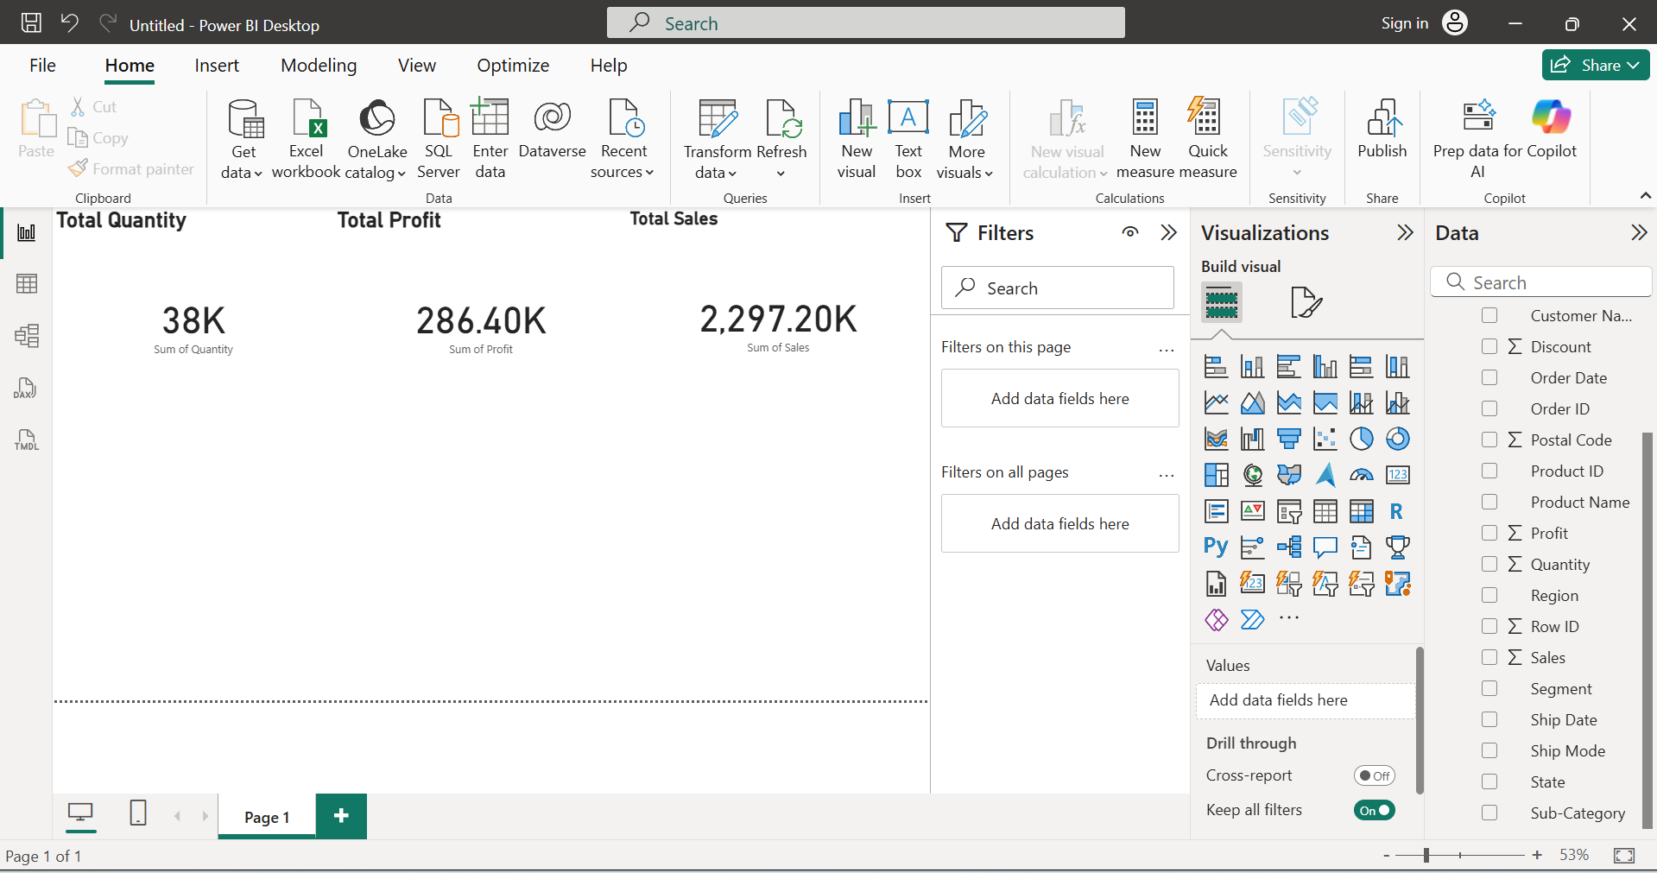

**Create a Line Chart (Sales Trend Over Time)**

**Goal:** Show how sales change over months or years.

Selected the Line chart from the Visualize tab and drag and droped the sales, profit and order date to find the sales trend

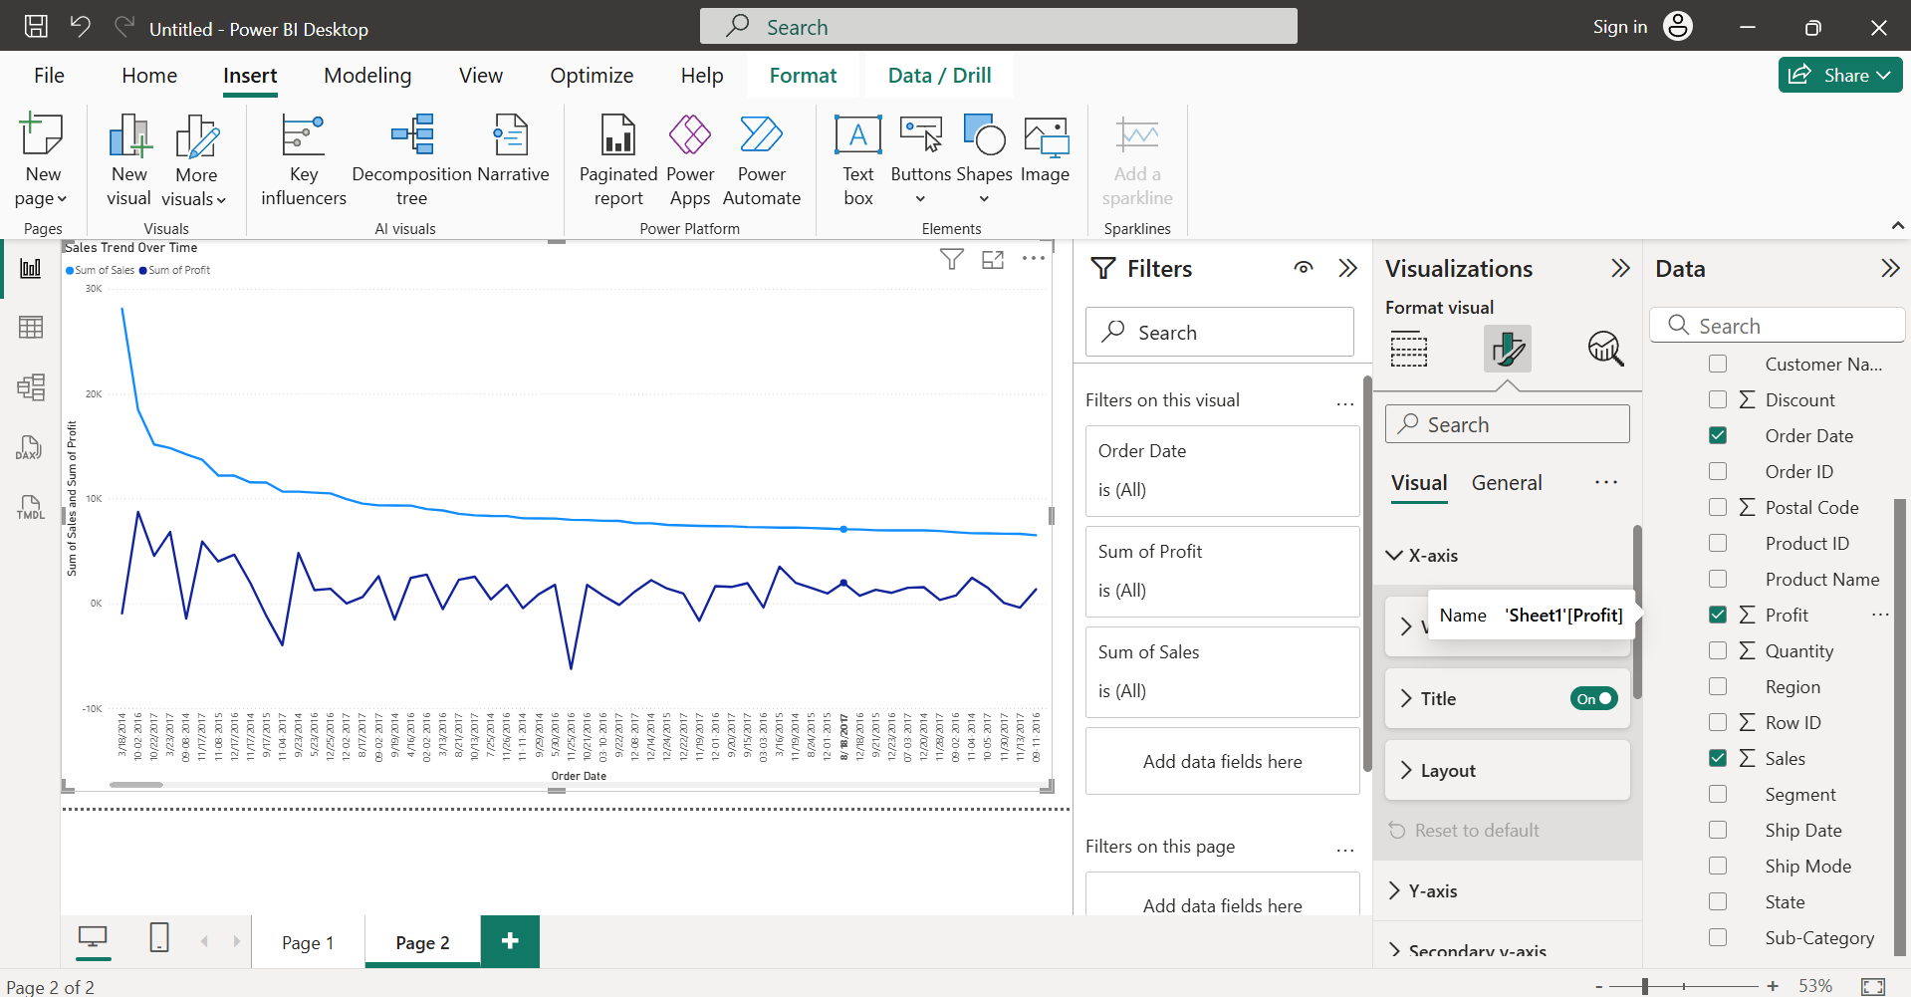

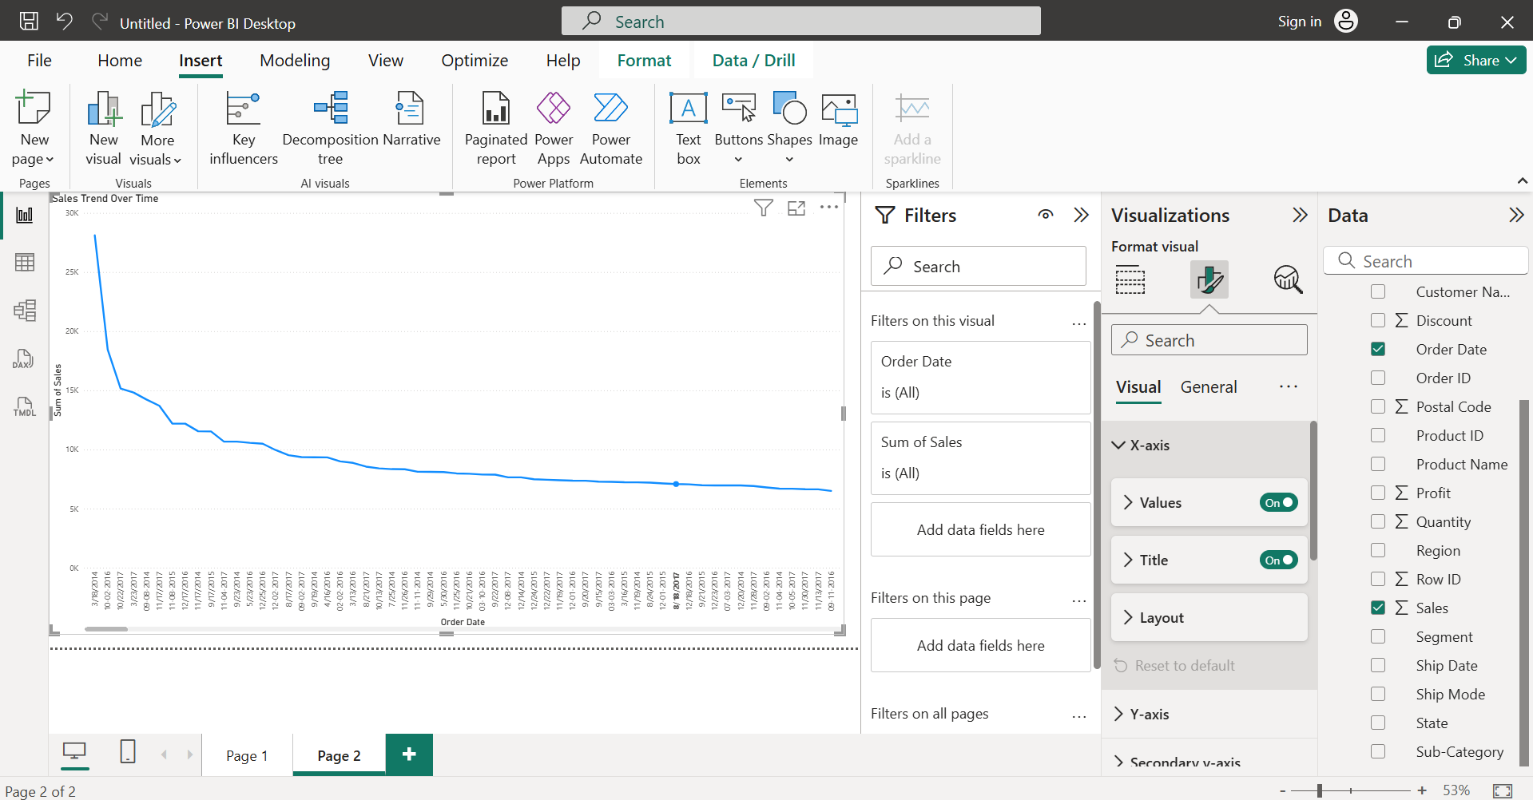

**Create a Bar Chart (Profit by Region)**

**Goal:** Compare profit across regions.

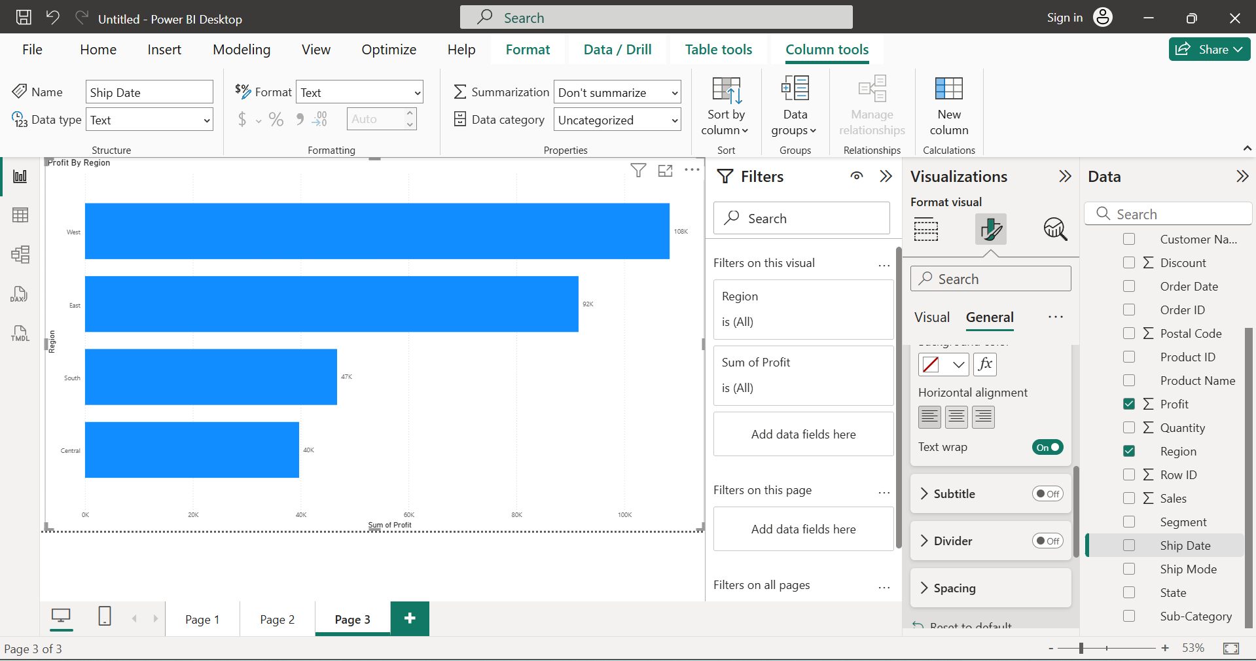

**Create a Scatter Plot (Discount vs Profit)**

**Goal:** Show how discount impacts profit.

Applying color formatting for the different category

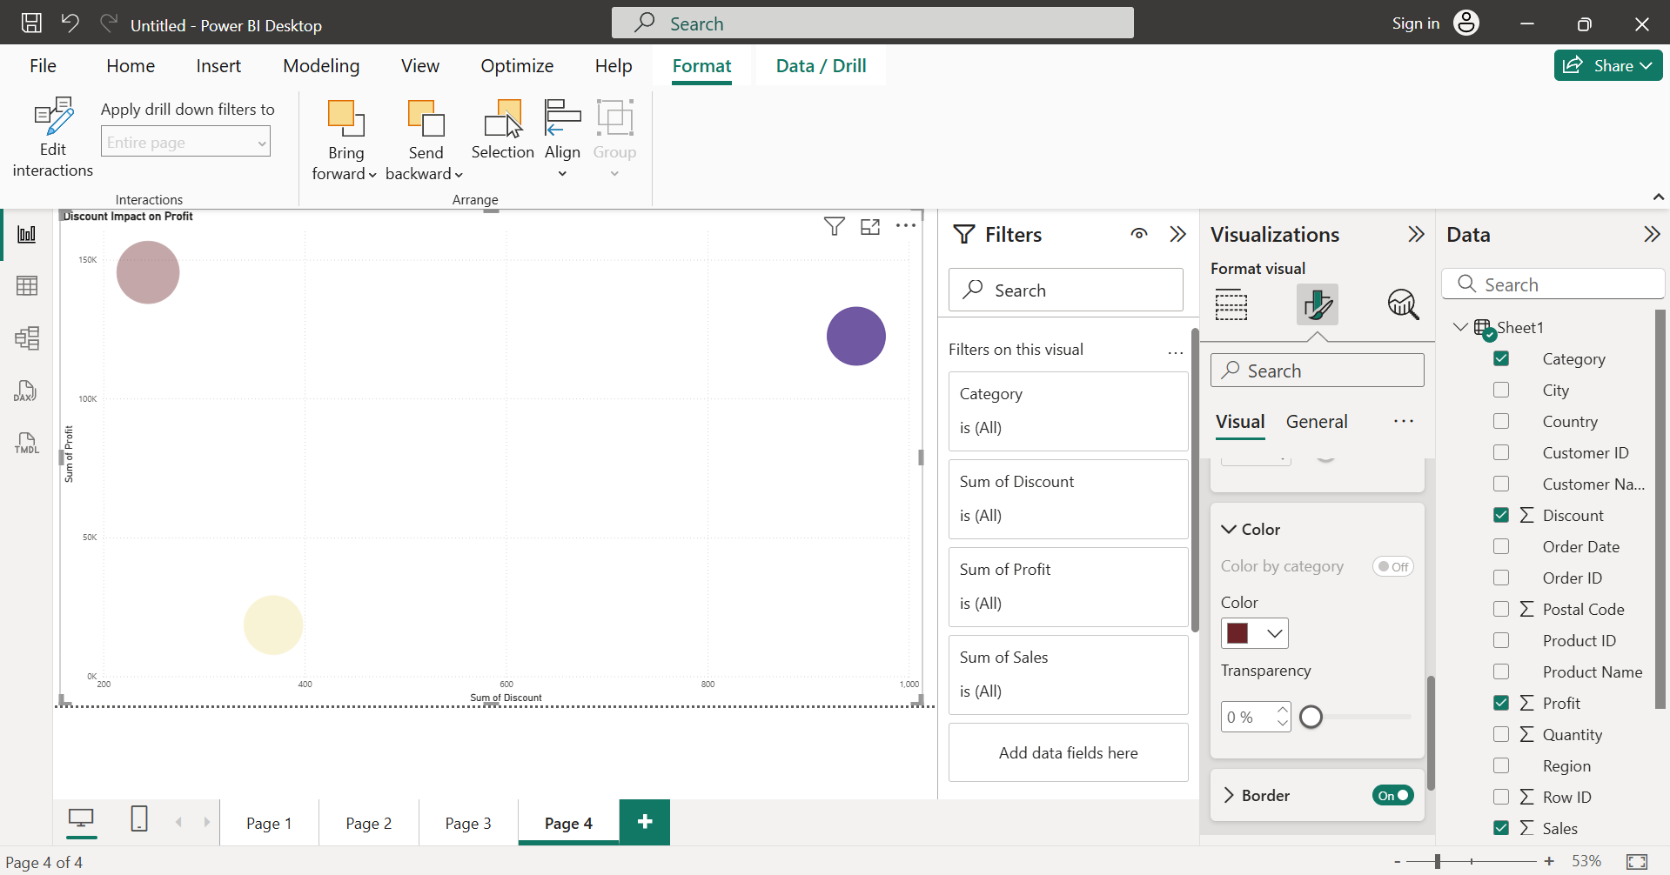

**Create a Donut Chart (Segment or Region Share)**

**Goal:** Show composition (which segment contributes most to sales).

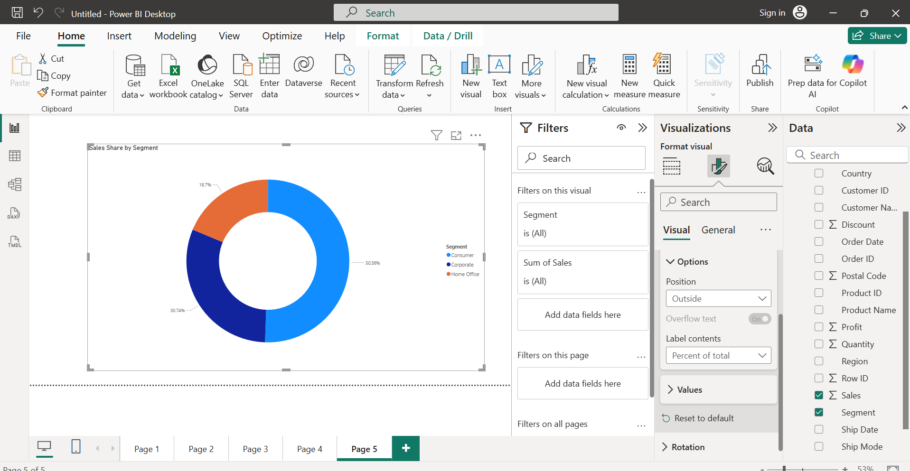

2.Avoid clutter and overuse of colors

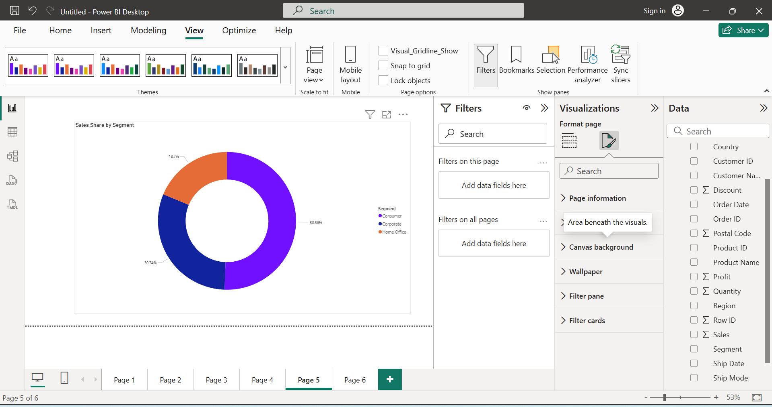

3.Highlight key takeaways

**Goal:**

Draw attention to what matters ex: profit trends, top performers, problem areas.

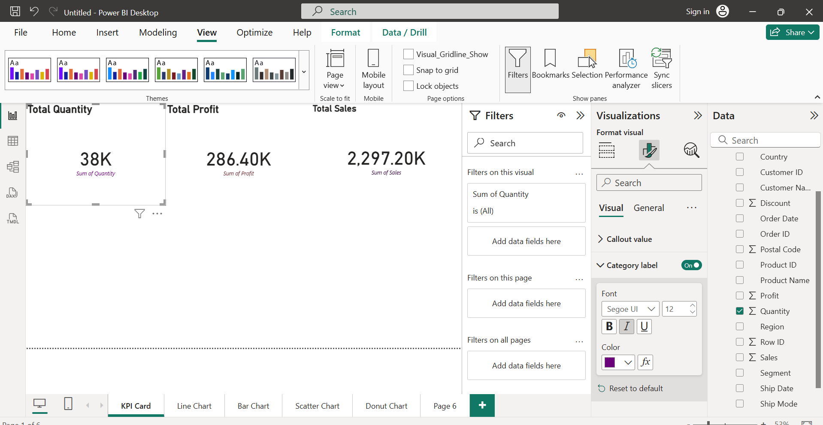

**4. Add context to each chart**

To let others understand why the chart matters, not just what it shows.

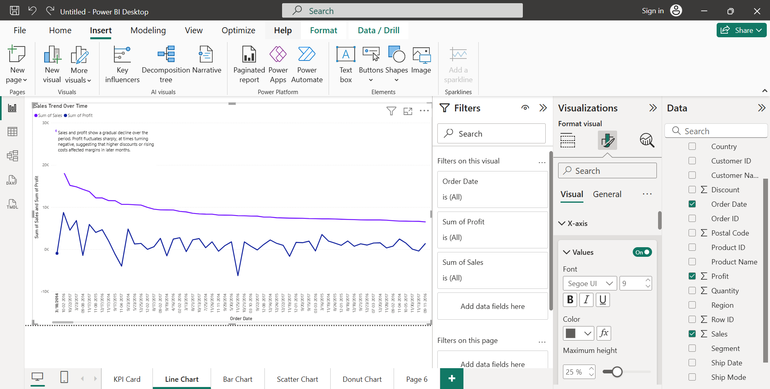

5.Focus on business insights, not just visuals

**Ask Business Questions**

Before building visuals, decide what business story you’re answering:

* Which region gives the most profit?

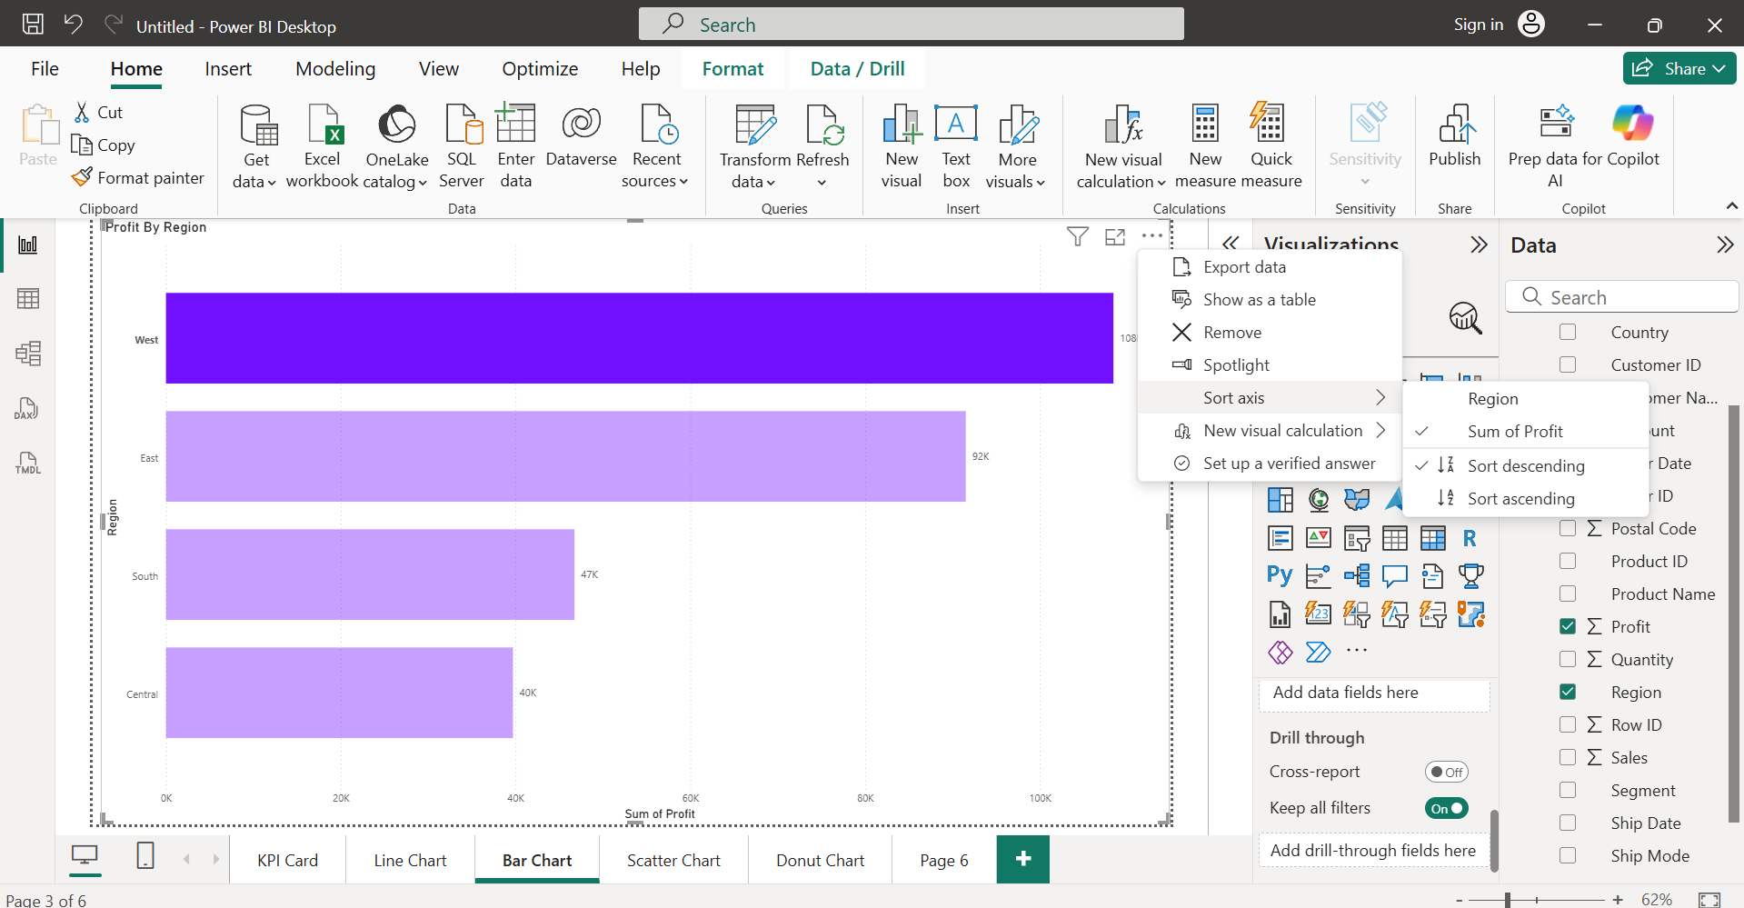

6.Create summary slide/storyboard

